**NAME : SALMA RANI**

**SAPID : 54194**

**CLASS TASK : WAD**

**SUBMITTED TO : MAM NAYAB**

**Task 1:**

<!DOCTYPE html>

<html>

<head>

<body>

    <body style="background-color: aquamarine;">

        <h1>this is heading</h1>

        <p>this is paragraph</p>

    </body>

</head>

</html>



**Task 2:**

<!DOCTYPE html>

<head>

<body>

    <a href="https://www.w3schools.com/">This is a link</a>

    <img src="C:\Users\pc solution\Desktop\ima.jpeg">

</body>

</head>

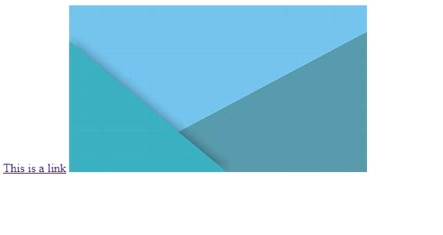

**Task 3:**

<!DOCTYPE html>

<head>

    <body>

        <p>

            Browsers usually indent blockquote elements

        </p>

        <blockquote>

            you can teach a student a lesson for a day,but if you can teach him to learn....

        </blockquote>

    </body>

</head>

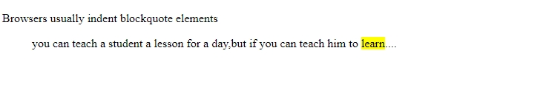

**Task 4:**

<!DOCTYPE html>

<head>

<body>

    <p>

        <h1>This is heading</h1>

        <br>

        <h2>This is heading</h2>

        <br>

        <h3>This is heading</h3>

        <br>

        <h4>This is heading</h4>

        <br>

        <h5>This is heading</h5>

        <br>

        <h6>This is heading</h6>

    </p>

</body>

</head>

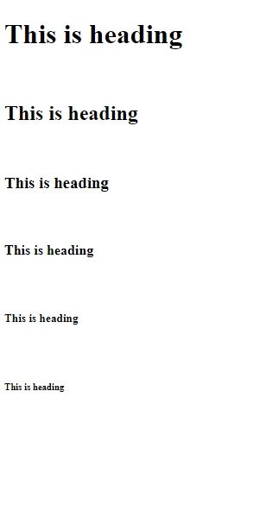

**Task 5:**

<!DOCTYPE html>

<head>

<body>

        <b>Bold text</b>

        <strong>important text</strong>

        <i>italic</i>

        <em>empshasized</em>

        <mark>marked</mark>

        <small>small text</small>

        <del>deleted text</del>

        <ins>inserted text</ins>

        <sub>subscript</sub>

        <super>super</super>

        <q>for something </q>

</body>

</head>



**Task 6:**

<!DOCTYPE html>

<head>

<body>

    <h2>an unordered list</h2>

    <ul>

        <li>coffee</li>

        <li>tea</li>

        <li>milk</li>

    </ul>

</body>

</head>

